**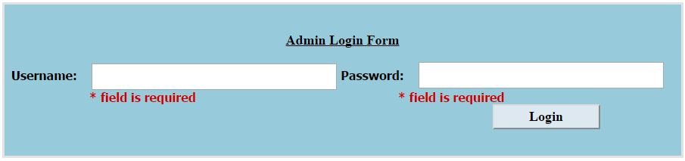1. Admin Login***Empty Field Validation*

**2. Booking**

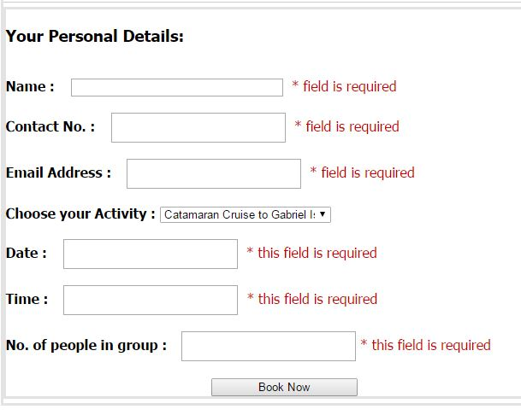*Empty Field Validation*

*Characters Validation*

*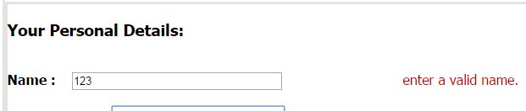*

*Number Validation*

*C:\Users\DRSH\Desktop\test plan\booking_numbervalidation.JPG*

*Email Validation*

*C:\Users\DRSH\Desktop\test plan\booking_emailvalidation.JPG*

*Date Validation*

C:\Users\DRSH\Desktop\test plan\booking_datevalidation.JPG

*Time Validation*

*C:\Users\DRSH\Desktop\test plan\booking_timevalidation.JPG*

**3. Enquiry Form**

*Empty Field Validation*

*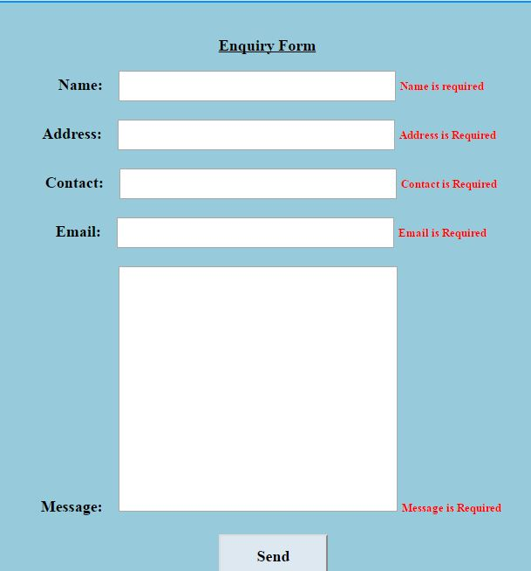*

**4. Add User Validation**

**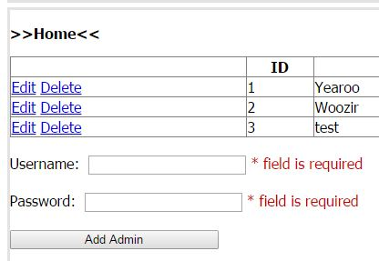**

**5. Add Activity Validation**

**